**HOME PAGE:**

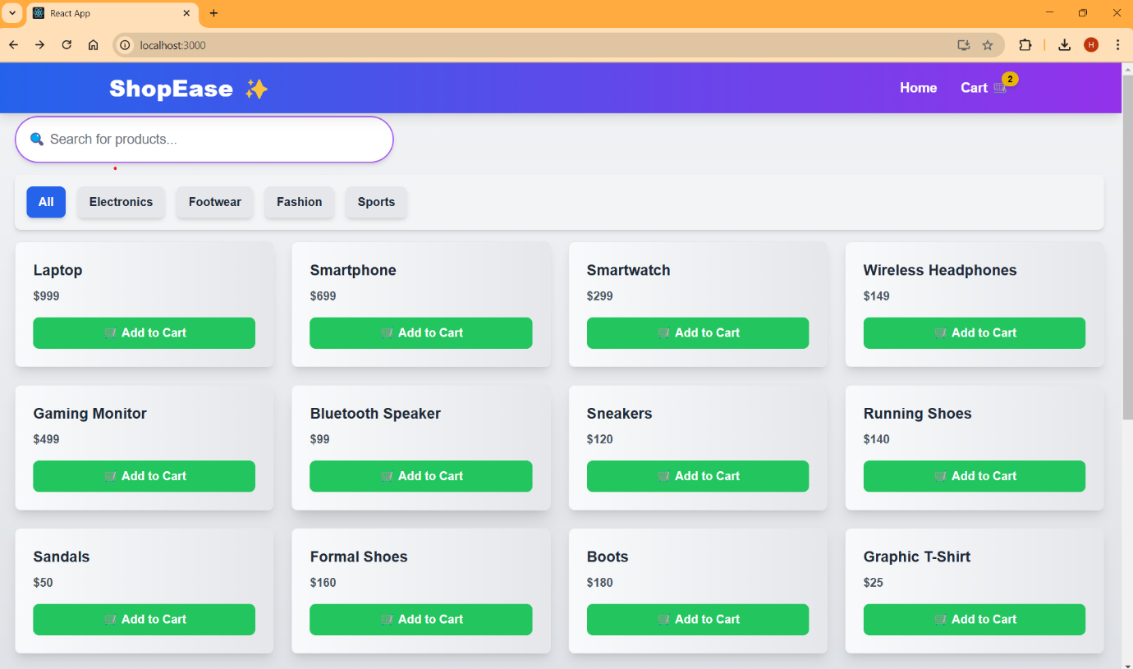

**VARIOUS CATEGORIES:**

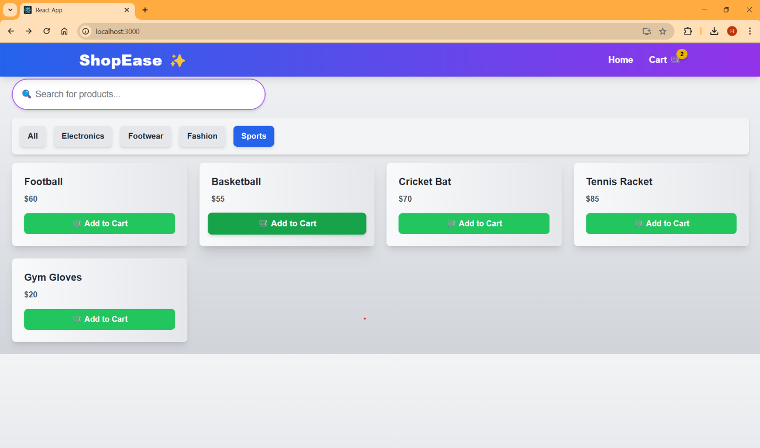

**SEARCHING FOR PRODUCT:**

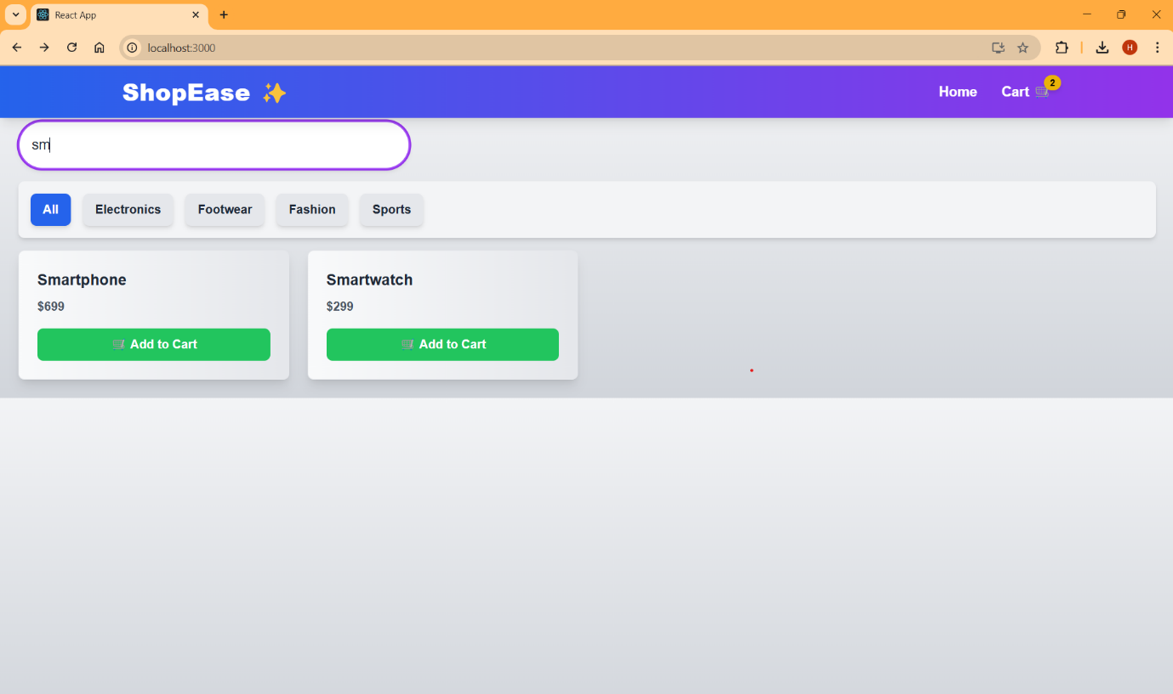

**ADDING PRODUCT TO CART:**

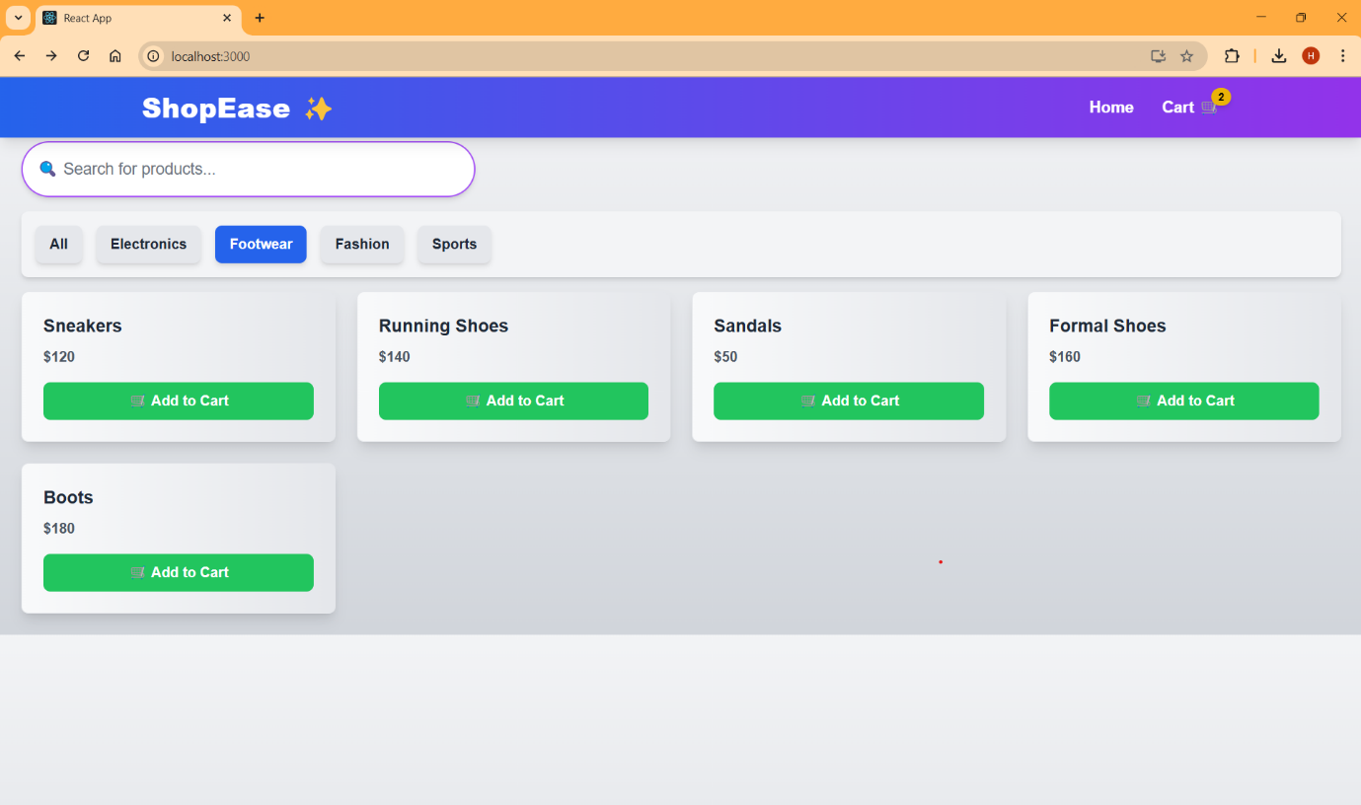

**VIEWING CART:**

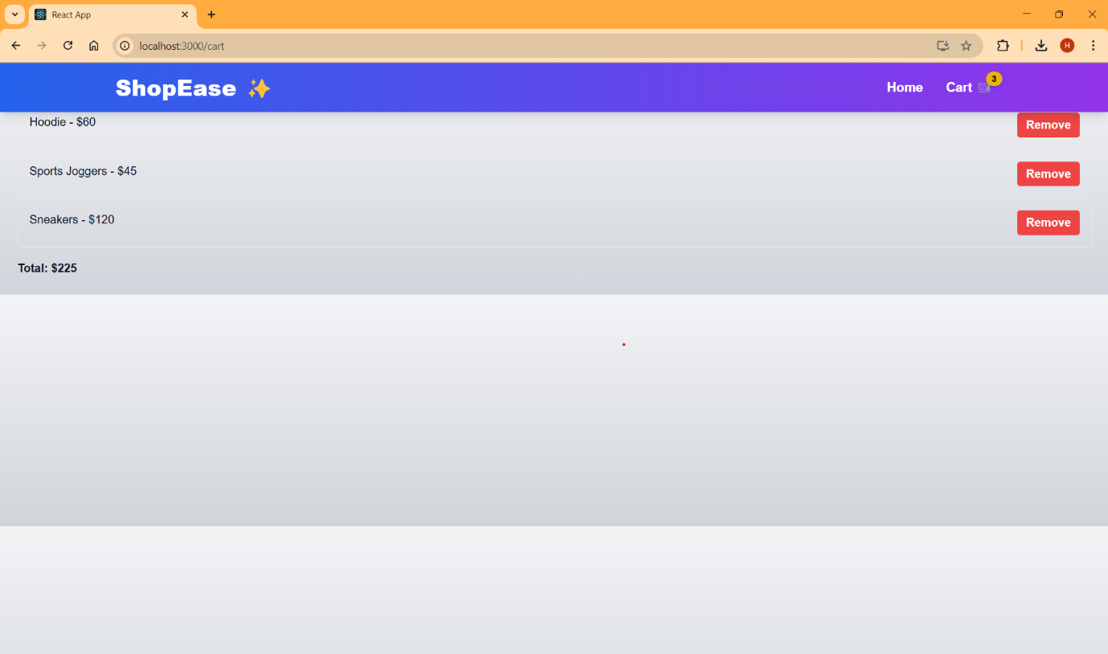

**REMOVING ITEM FROM CART:**

